**USER INSTALLATION MANUAL**

Software to be installed before running the .exe file:

1. Qt-creator

2. PostgreSql

3. GDAL.

## Installing Qt Creator:

* Install Qt Creator from the following link with the **default settings**.
* Link to install: [qt-opensource-windows-x86-mingw492-5.6.1.exe](https://download.qt.io/official_releases/qt/5.6/5.6.1/qt-opensource-windows-x86-mingw492-5.6.1.exe)
* Add *“C:\Qt\Qt5.6.1\Tools\mingw492_32\bin\”* and *“C:\Qt\Qt5.6.1\5.6\mingw49_32\bin\”* to PATH environment variable.
* Create a new variable named **QT5_ROOT_PATH** and set the value to *“C:\Qt\Qt5.6.1\5.6\mingw49_32\bin\”*.

## Installing PostgreSQL and PostGIS:

* Install “**PostgreSQL 9.3 64 bit version**” into the **default path (please try to install it in the default path)**.
* While installing PostgreSQL, try to keep both **username and password as “postgres” and the port 5432** for convenience.
* After installing PostgreSQL, install only PostGIS2.2 bundle for your system from Stack Builder.
* Add folders *“C:\Program Files\PostgreSQL\9.3\bin”* and *“C:\Program Files\PostgreSQL\9.3\lib”* to PATH environment variable.

## Database Manual:

To run Dharohar application with the database, make sure the database server accepts remote connections. To access the database server remotely, the network address of the server must be mentioned in the **pg_hba.conf** file.

One more thing that you need to be sure of is that appropriate PostGIS Bundle for PostgreSQL database should be installed on the machine to make Dharohar work properly.

### Create new database:

After creating a new database, run the SQL script “setupDatabase.sql” on the database. You can run it on the postgress shell /pg admin or command line. To run the script from command line, follow the syntax below.

*psql –U “username” -d “database_name> -h “host_address” -p “port” < setupDatabase.sql*

setupDatabase.sql file is attached with this document.

To run it from the shell or PG Admin, copy the contents of the file an paste it in the shell.

Provide the password of the user on prompt.

### Creating Schema:

Open the shell of the postgress and log into it with proper credentials.

Server:

Database: dhar_db

Port:5432

Username: postgresPassword: postgres

To connect to the database, use the command \c dhar_db; and press enter key.

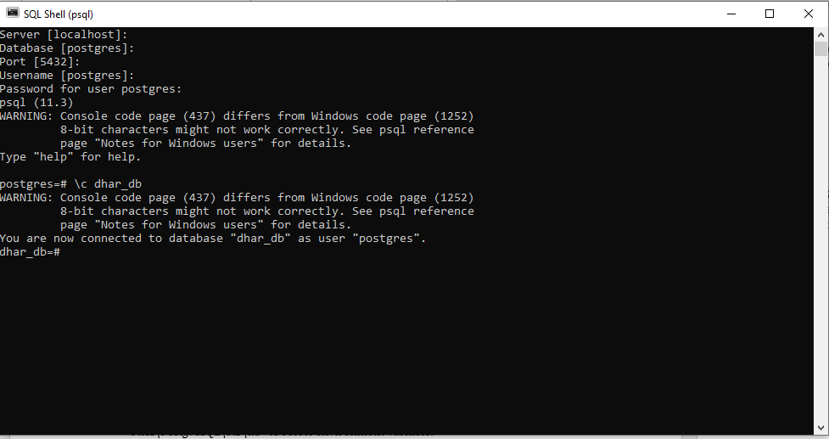

Copy the contents of the file schema.txt and then paste in the shell and press enter.

## **GDAL INSTALLATION:**

Install the requied gdal according to your processesor requirements.

Gdal can be download from the website <http://gisinternals.com/>

Go to **Archive Versions**:

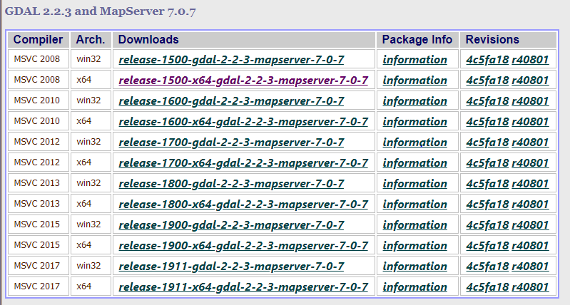

**Note:** MSC v.1500 may differ if you are using a different Python installation, if it does then please make a note of that number. Note, if you installed the 64-bit version of Python, for the rest of the tutorial **please remove the (x86)** from the paths.

To check the MSC run python (command line) or run IDLE in python.

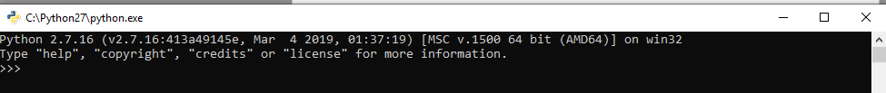

We are using the MSC v.1500 on a 32-bit system, the picture below illustrates how to match the version with your own python version. The Arch. is where you should look for either 64-bit or 32-bit systems, and the Downloads shows the release-1500 number which should match the number from IDLE.

Clicking the link will take you to the list of binaries (installers) to download

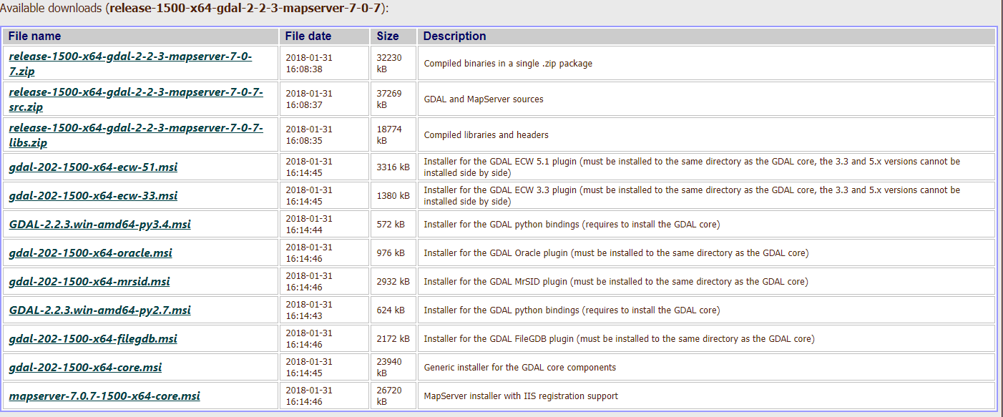

Locate the “core” installer, which has most of the components for GDAL.

After downloading your version, install GDAL with standard settings.

|  |  |
| --- | --- |
| Add 1 | ;C:\Program Files (x86)\GDAL |

to PATH environment variable.

Then create a new variable named **GDAL_DATA** and set the value to C:\Program Files\GDAL\gdal-data.

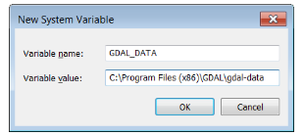

Add one more new variable by clicking “New…” Add the following in the dialogue box:  
Variable name: GDAL_DRIVER_PATH  
Variable value: C:\Program Files (x86)\GDAL\gdalplugins  
Click “OK”

**Create a text(.txt) file on the desktop with the name text.**

**Open properties of the file -> Security ->Edit -> Add -> everyone -> ok-> In permissions for Everyone, allow full control -> Apply -> OK.**

**Whenever you use the button Save to DB, for the file, give the permissions.**

**Open properties of the file -> Security ->Edit -> Add -> everyone -> ok-> In permissions for Everyone, allow full control -> Apply -> OK.**

**NOTE: Proper installation of postgreSql, postgis and gdal is required for saving purpose. Without these softwares saving will not happen.**